**GREENNIT HIGH LEVEL DESIGN**

1. Use cases diagrams

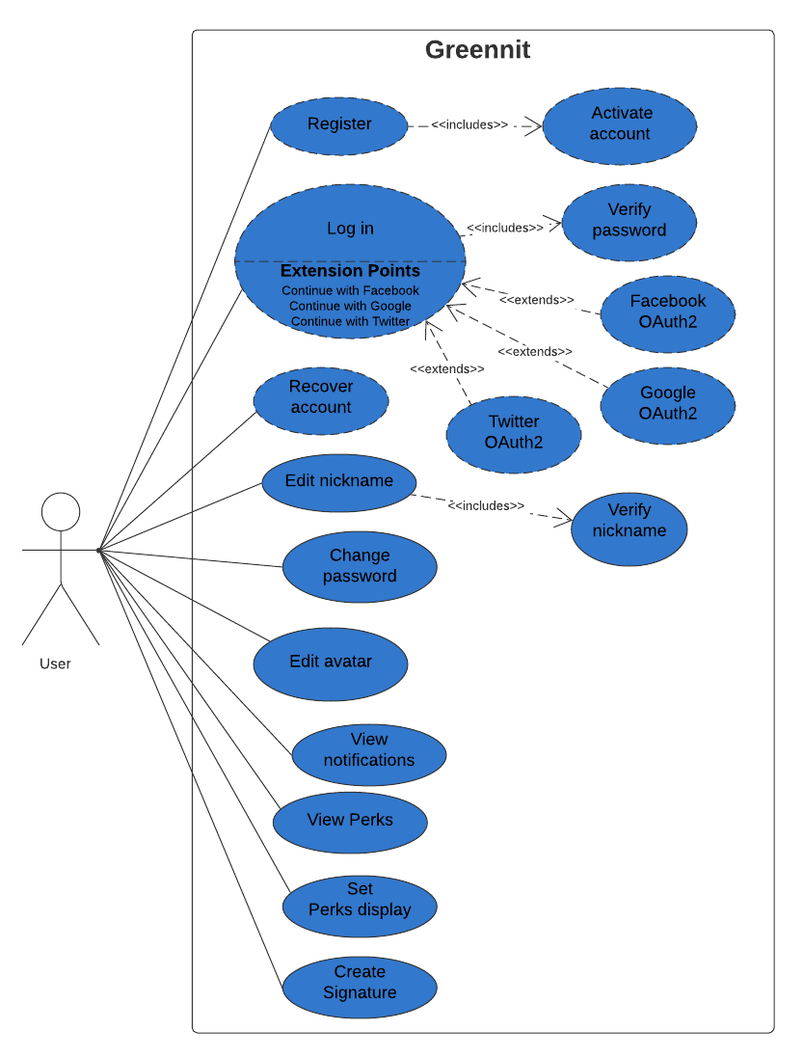

Figure 1. User use cases

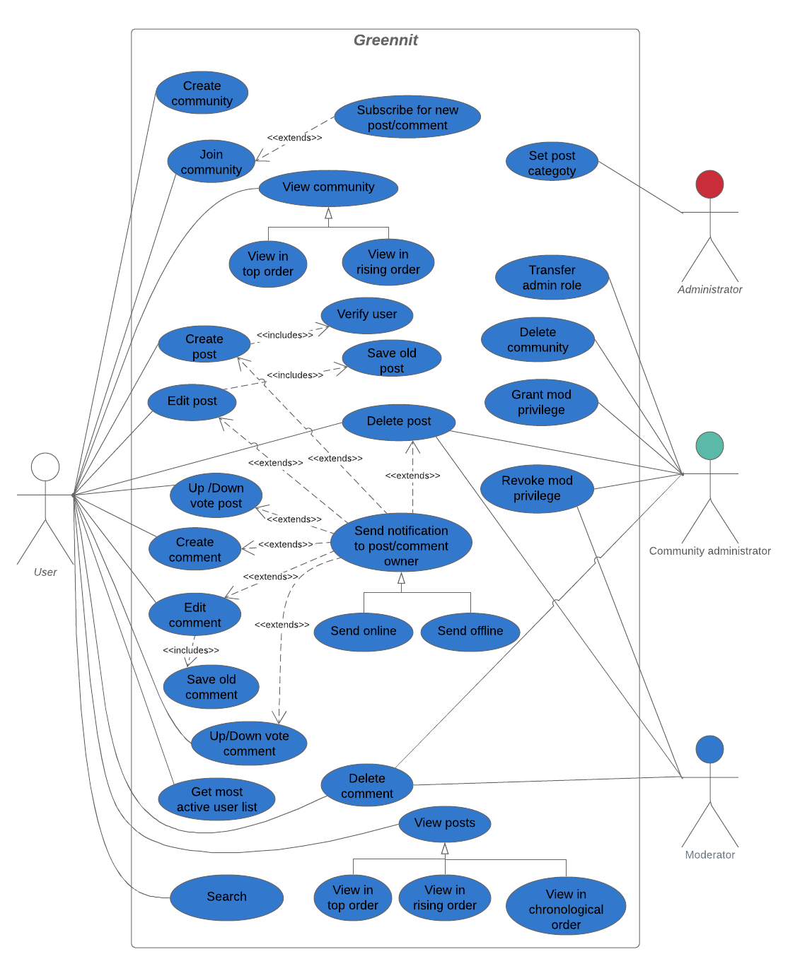

Figure 2. Community, post and comment use cases

1. High level architecture diagram

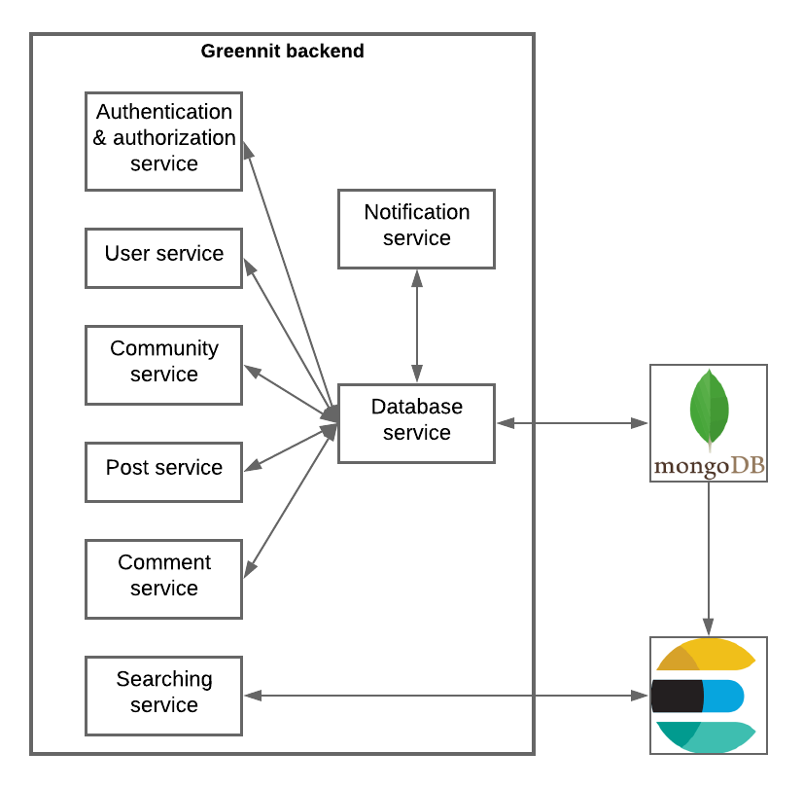

Figure 3. High level architecture diagram

1. Sequence diagrams